ASSIGNMENT TWO – Optimize the two-dimensional Rastrigin function

Quang Thong Phung

ENGR 5010G - Advanced Optimization

Instructor: Dr. Asif Khan

2025-07-31

**Introduction**

Optimization of the Rastrigin function in two-dimensional space:



Where $x, y ∈\left[-5.12,5.12\right]$. The function has a global minimum at $\left(0, 0\right)$ with $f\left(0, 0\right)=0$, surrounded by many deceptive local minima.

In this report, I implement and evaluate three metaheuristics: Genetic Algorithm (GA), Differential Evolution (DE), and Particle Swarm Optimization (PSO). The objective is to determine which algorithm performs most effectively under identical experimental conditions and to draw conclusions about their strengths and weaknesses

**Algorithm Descriptions**

**Genetic Algorithm (GA):**

Overview: Genetic Algorithm (GA) is a population-based optimization technique inspired by the process of natural selection and genetics. It uses selection, crossover, and mutation operations to find better solutions.

Components:

* Selection
* Crossover
* Mutation
* Elitism

Parameters:

* Population size
* Mutation rate
* Number of generation

**Particle Swarm Optimization (PSO):**

Overview: Particle Swarm Optimization (PSO) is inspired by the behavior of birds flocking fish schooling, ant. Each particle represent a solution and move through the search space by adjusting its velocity based on its own experience and that of the entire swarm

Components:

* Position and velocity
* Personal best
* Global best
* Velocity update

Parameters:

* Inertia weight $w$
* Cognitive coefficient, social coefficient
* Swarm size, number of generations

**Differential Evolution (DE)**

Overview: Differential Evolution (DE) optimizes problems by iteratively improving candidate solutions using differential mutation and recombination.

Components

* Mutation
* Crossover
* Selection

Parameters

* Scaling factor $F$
* Crossover rate $CR$
* Population size, number of generations

**Experimental Setup**

Minimize the two-dimensional Rastrigin function:



Settings for All Algorithms:

* **Dimensions:** 2
* **Search bounds:** [-5.12, 5.12]
* **Population / Swarm size:** 50
* **Number of generations (iterations):** 100
* **Initialization:** Fixed random seed (42) to ensure identical initial population across all algorithms
* **Termination criterion:** Fixed number of generations
* **Programming environment:** Python 3 with NumPy and Matplotlib for implementation and visualization

Configure each algorithm:

GA:

* Mutation rate: 0.1
* Selection method: Roulette wheel
* Crossover: Single-point crossover
* Elitism: Best individual is preserved

PSO:

* Inertia weight $w=0.7$
* Cognitive coefficient $c_{1}=1.5$
* Social coefficient $c_{2}=1.5$
* Velocity initialized = 0

DE:

* Scaling factor $F=0.5$
* Crossover rate $CR=0.9$
* Mutation strategy: DE/rand/1/bin

**Convergence plots and tables summarizing best fitness**

GA:

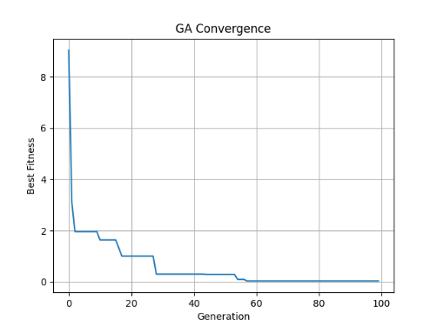

Fig 1. *Convergence plot of the Genetic Algorithm (GA) over 100 generations*

|  |  |  |  |
| --- | --- | --- | --- |
| **Generation Mark** | **Best Fitness** | **x** | **y** |
| Generation 1 | 9.043371 | 1.03542 | 2.13066 |
| Generation 57 (near best value) | 0.093182 | |  | | --- | |  |   -0.02072 | 0.00639 |
| Generation 100 (best overall) | 0.034176 | |  | | --- | |  |   0.01147 | 0.00639 |
| Generation 100 | 0.034176 | 0.01147 | 0.00639 |

Table 1. *Summary of GA Results at Selected Generations*

PSO:

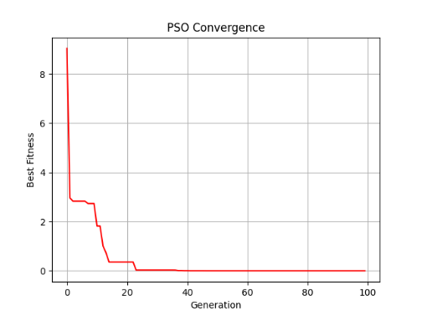

Fig 2. *Convergence plot of the* Particle Swarm Optimization (PSO) *over 100 generations*

|  |  |  |  |
| --- | --- | --- | --- |
| **Generation Mark** | **Best Fitness** | **x** | **y** |
| Generation 1 | 9.043371 | 1.03542 | 2.13066 |
| Generation 71 (near best value) | 0.000007 | |  | | --- | |  |   -0.00018 | -0.00006 |
| Generation 72 (best overall) | 0.000000 | |  | | --- | |  |   -0.00002 | 0.000000 |
| Generation 100 | 0.000000 | 0.000000 | 0.000000 |

Table 2. *Summary of PSO Results at Selected Generations*

DE:

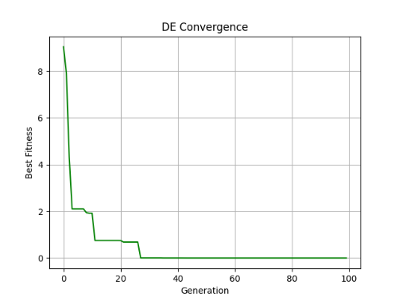

Fig 3. *Convergence plot of the* Differential Evolution (DE) *over 100 generations*

|  |  |  |  |
| --- | --- | --- | --- |
| **Generation Mark** | **Best Fitness** | **x** | **y** |
| Generation 1 | 9.043371 | 1.03542 | 2.13066 |
| Generation 54 (near best value) | 0.000002 | |  | | --- | |  |   0.00007 | 0.00006 |
| Generation 55 (best overall) | 0.000000 | |  | | --- | |  |   -0.00002 | 0.00003 |
| Generation 100 | 0.000000 | 0.000000 | 0.000000 |

Table 3. *Summary of DE Results at Selected Generations*

**Comparative discussion with insights and recommendations**

**Insights:**

* GA maintains good diversity because it uses crossover and mutation operations, which helps it avoid getting stuck at local extremes. However, the convergence speed of GA is slower.
* PSO converges quickly in early generations, but often gets stuck at local extrema.
* DE gives the most stable and accurate results of all three algorithms. It performs well on complex search spaces, has strong global exploration ability, and converges reliably.

**Recommendations:**

For problems with many local extrema like Rastrigin, Differential Evolution (DE) is the recommended algorithm due to its stability and solution quality. In the future, we can use hybrid methods (e.g. GA-DE or PSO-DE) that can be further studied to combine speed and exploration ability.

**REFERENCES**

M. S. A. Khan, S. M. Sait, and A. M. Sagheer, “Performance comparison of Genetic Algorithm, Differential Evolution and Particle Swarm Optimization towards benchmark functions,” in *Proc. 3rd Int. Conf. Adv. Comput. Sci. Appl. Technol. (ACSAT)*, Kuala Lumpur, Malaysia, 2014, pp. 105–110. doi: 10.1109/ACSAT.2014.34